Attachment A

- Detailed Scope of Work ………………….……………

- Instructions for Response ……………………………..

- Scoring of the RFP …….……….……………………...

- Detailed Scope of Work

It is the intent of Community Healthcore to contract through the competitive bid process a licensed General Contractor to complete a construction remodel as per the specification and drawing to be provided at 101 E. Madison Gilmer, Texas 75644. The facility is approximately 1 Southeast of downtown Gilmer and just North of Hwy 271.

- Specification/Requirements
  - Plans with detailed scope of work will be available for pickup at one of the required pre-bid walk-thru on March 28th anytime between 8:30 and 11:00 am or March 27th anytime between 8:30 and 11 am

- Demo approximately 1200 square feet inside the facility, no work to be completed on the exterior as indicated on attached drawings
- Asbestos Survey and abatement have been completed (documents will provided to contractor awarded the RFP)
- Seal off one half of building that will continue to provide services during construction.
- Remodel construction will include building out 2 exam rooms, a nurse/ lab area, a new HVAC closet, 2 accessible restrooms and new hallway as indicated on attached drawings
- Contractor will be responsible for filing permits, completing the demo and remodel, hiring and supervising licensed subcontractors as needed, finish and cleanup.
- General Contractor will meet the prevailing wage requirements for Upshur county and will provide a detailed timesheet along with invoicing to assure those guidelines have been met, (Davis Bacon act posters will be provided to post at the job site. A copy of the most recent prevailing wage requirement for Upshur county can be provided upon request.
- It is estimated that this Request for Proposal will be awarded by the end of April. The work will be must be able to be completed by August 1st, 2023

Locations open for Bid: 101 E Madison Gilmer Texas 75644.

- Instructions for Response

- Pricing

  - Site specific: Please provide bid for this project that includes the detailed scope of work from start to finish for the project.

- Staffing

- Specify how the project will be supervised.
- Specify if employees work directly for your organization or if they are contracted.
- Also specify how quality will be monitored and documented to meet requirements.
- Specify how employees will be identified while on CHC property. (i.e. truck marked with signage)

- References

  - Community Healthcore requests Responder to supply, with this RFP, a list of at least three (3) professional references where like services have been supplied by their firm. Include name of firm, address, telephone number and name of representative.

- Other
- Proposal should provide a technical response to specification in detailed scope of work
- Affirm/demonstrate the Proposers to meet all of the Minimum Standards for all Prospective Responders.
- Acknowledgements of RFP and all RFP Addenda’s
- A minimum of three (3) references
- Other documents as included below
- Return signed Conflict of Interest Questionnaire (Attachment B)
- Responder shall provide in their proposal all documentation required by this RFP. Failure to provide this information may result in rejection of proposal.
- MINIMUM STANDARDS FOR ALL PROSPECTIVE RESPONDERS: A prospective Responder must affirmatively demonstrate / meet the following requirements:

  - Have adequate financial resources, or the ability to obtain such resources as required; Please specify this within the proposal;
  - Be able to comply with the required or proposed delivery schedule. Include all details as appropriate including staffing levels, supervision, and how Responder will monitor the service;
  - Have a satisfactory record of performance evidenced by references;
  - Have a satisfactory record of integrity and ethics;
  - Have the ability to provide usage data on items ordered or delivered;
  - Have the ability to package and mark items for specific Community Healthcore units;
  - Be able to provide descriptive information as required, including detailed scope of work to be provided and frequency if applicable;
  - Be otherwise qualified and eligible to receive an award; and,
  - Meet any additional requirements specified in the RFP.

- OTHER DOCUMENTS: Responder shall provider with this proposal copies:

    - Current workman compensation policy;
    - Proof of insurance as required. See Attachment C, Exhibit A;
    - Bank Reference letter or financial statement proving financial stability.

- Scoring of the RFP

- Factors to be considered include:

- Any installation cost;
- Delivery terms;
- Quality and reliability of respondents goods or services;
- The extent to which the goods or services meet the CENTER’s needs as described in this RFP;
- Past offeror performance, respondents financial resources and ability to perform, the respondent's experience and responsibility, and the respondent's ability to provide reliable service agreements
- The impact on the ability of CENTER to comply with laws and rules relating to historically underutilized businesses or relating to the procurement of goods and services from persons with disabilities;
- The total long term cost to the local authority of acquiring the respondent's goods or services;
- The cost of any CENTER employee training associated with the acquisition;
- The effect of the acquisition on CENTER’s productivity;
- Price
- Whether the respondent can perform the contract or provide the service(s) within the contract term, promptly provide the services, without delay or interference;
- Respondent’s history of compliance with the laws relating to its business operations and the affected service(s) and whether it is currently in compliance;
- Whether the respondent’s financial resources are sufficient to perform the contract and to provide the service(s);
- Whether necessary or desirable support and ancillary services are available to the respondent;
- The character, responsibility, integrity, reputation, and experience of the respondent;
- The quality of the facilities and equipment available to or proposed by the respondent;
- The ability of the respondent to provide continuity of services;
- The ability of the respondent to meet all applicable written policies, principles, and regulations;
- Any factor is relevant to determining the best value for Community Healthcore in the context of this procurement.

- Proposals will be scored using the following criteria:

These factors will be considered and some may be given greater weight than others

Categories | Points
1-Organizational History and Experience | 100
2-Service delivery based on specifications | 250
3-Pricing and other cost | 300
4-Operational start date | 100
total | 750

Multiple vendors may be awarded a contract based on the best value rate for the organization at the locations listed in the chart.

Please direct any questions you have about this specification to (903) 234-7001 or email Tom.Suess@communityhealthcore.com

Attachment A-1 Questions (answer can be provided on this sheet or add an attachment)

1- Organizational History and Experience
Responder should provide a description of responder’s organization or business, outlining its experience as a General Contractor provider. Tell us what sets you apart from other similar service providers. Please describe another project you have completed that is similar to this one.

2- Service Delivery

Responder should describe what measures are in place to meet the specifications listed in this proposal. Include any follow up monitoring, internal auditing, and Supervision that may be used to monitor specs are being met. It is crucial that these schedules for service are met. Describe measures in place to accommodate when there are workforce or weather issues.

3- Pricing and Other Cost
You may submit a separate sheet with your bid proposal or use the table below to fill in your bid for this project.

Organization/Business Name | Total Bid Cost | Estimated start if awarded by May 1, 2023 | Estimated Completion Date

4- Operational Start Date
If awarded a contract by May 1st 2023, can the responder `be able to complete the project by August 1, 2023?

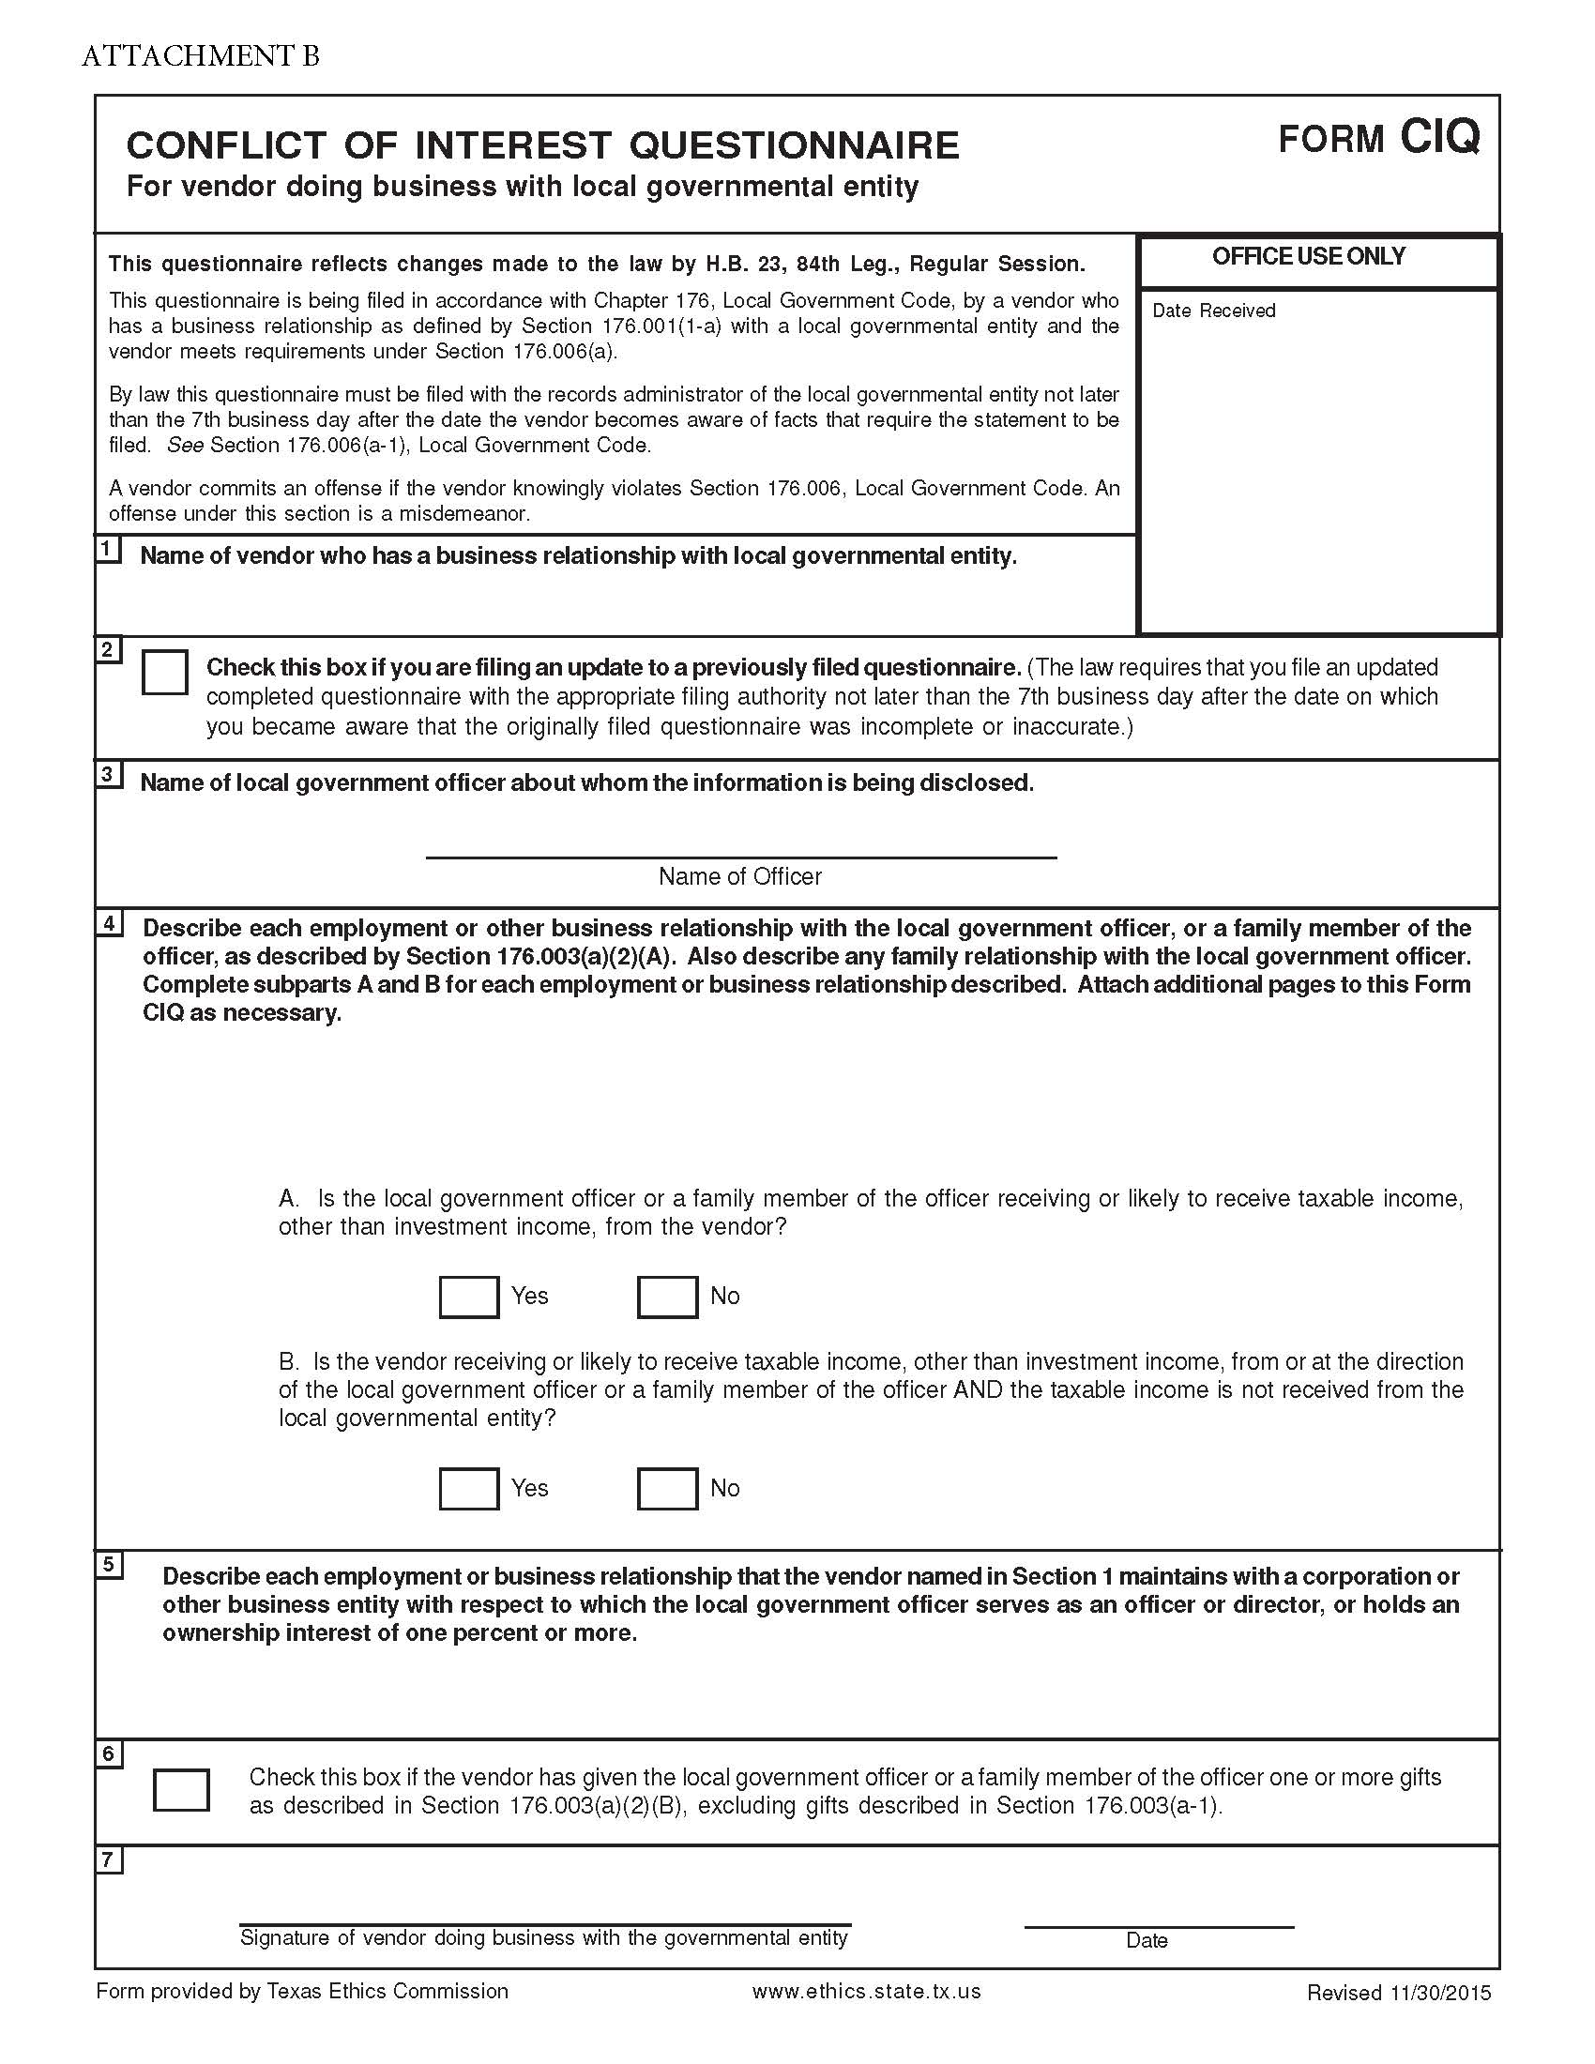

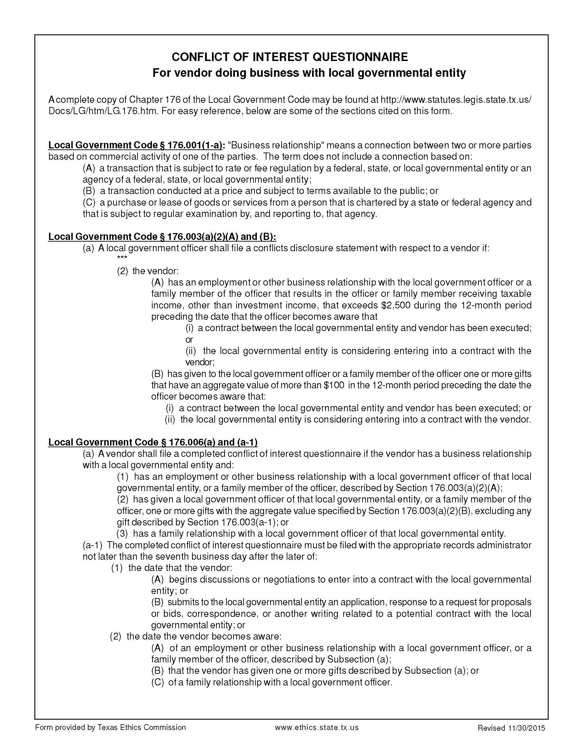

ATTACHMENT D – RESPONDENT’S INFORMATION SHEET

Name of Legal Entity and Doing Business As (d/b/a) Name, if applicable

Respondent’s Representative

Respondent’s Mailing Address

Respondent’s Email Address

Respondent’s Telephone Number

I/We ____________________________________________________________________________
Company Name

Located at ________________________________________________________________________
Company Address

hereby submit our proposal. This proposal is made without collusion on the part of any person, firm or corporation.

Signature: __________________________________________________________________________________

Printed name: ______________________________________ Title: ___________________________________

Date: _________________________________

E-mail Address____________________________________________________

